Bacterial Blight Disease Detection on Pomegranate Leaf

A Synopsis Submitted
in Partial Fulfillment of the Requirements
for the Degree of
BACHELOR OF TECHNOLOGY
in

Department of Information Technology

by

Suraj Shivhari Darade [2021AIFT1111085]

Guided by

Dr. Vijaya Choudhari

G H Raisoni College of Engineering and Management
Wagholi, Pune
(An Empowered Autonomous Institute, Affiliated to SPPU, Pune,
Accredited by NAAC A+ Grade)

June, 2024

Synopsis
- Introduction

Pomegranates are more than just fruits; they are revered symbols of health, beauty, and cultural heritage across many civilizations. Known for their deep red color, sweet-tart flavor, and numerous seeds symbolizing fertility, pomegranates boast a rich nutritional profile, including high levels of antioxidants, vitamins, and minerals. They are celebrated not only for their taste but also for their substantial health benefits, such as anti-inflammatory, anti-cancer, and heart-protective properties, making them a staple in traditional medicine systems like Ayurveda and Traditional Chinese Medicine for centuries.
Beyond their health benefits, pomegranates hold significant cultural and economic value, particularly in regions such as the Middle East, Mediterranean, and South Asia, where they have been cultivated for thousands of years. However, the cultivation of pomegranates faces numerous challenges, the most formidable being bacterial blight disease caused by Xanthomonas axonopodis pv. punicae. This highly infectious disease spreads rapidly, causing symptoms like leaf lesions, twig dieback, and fruit rot, which severely affect both the yield and quality of the fruit, leading to substantial economic losses for farmers.
Addressing bacterial blight disease requires a combination of cultural and chemical control measures, including removing infected plant material, improving air circulation, and using copper-based bactericides. However, these methods have limitations, such as resistance development and environmental concerns. Therefore, there is an urgent need for sustainable and integrated disease management strategies, including developing resistant pomegranate varieties, using biological control agents, and adopting advanced agricultural practices like precision farming. Ongoing research and innovation are crucial to finding more effective solutions to combat this disease, ensuring the continued cultivation of pomegranates and safeguarding the livelihoods of farmers.
2.Literature Review

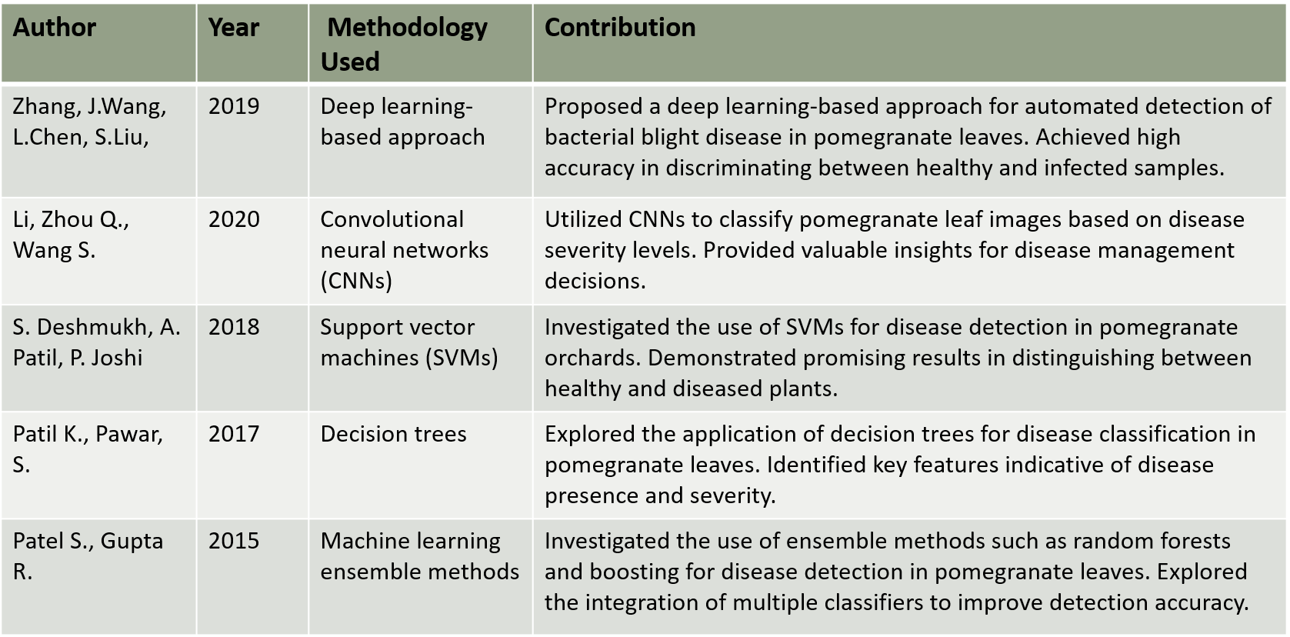

- Problem Statement

Bacterial blight disease, caused by Xanthomonas axonopodis pv. punicae, poses a significant threat to pomegranate cultivation worldwide, leading to severe yield losses, reduced fruit quality, and substantial economic damage to farmers. Current management practices, including chemical controls and cultural methods, have proven to be only partially effective, often limited by issues such as pathogen resistance, environmental concerns, and sustainability challenges. There is an urgent need for developing more effective, sustainable, and integrated disease management strategies, including the use of resistant pomegranate varieties, biological control agents, and advanced agricultural practices. Addressing this problem is critical to ensuring the long-term viability of pomegranate production, safeguarding farmer livelihoods, and maintaining the economic and cultural value of this important fruit crop.

4.Methodology

1.Data Collection:
Collect a diverse dataset of high-resolution images of pomegranate leaves from multiple orchards and regions. Include images with varying disease severities and environmental conditions to ensure robustness of the model.
2. Dataset Annotation and Preprocessing:
Annotate the collected images to label regions of interest corresponding to healthy and diseased areas of the leaves.
Preprocess the images by resizing, cropping, and normalizing pixel values to ensure consistency and facilitate efficient training.
3. Model Architecture Selection:
Choose an appropriate CNN architecture for disease detection tasks. Common choices include popular architectures like VGG, ResNet, or custom-designed architectures tailored to the specific requirements of the project.
4. Model Training:
Split the annotated dataset into training and test sets.
Train the selected CNN model on the training dataset using techniques as Adam optimization.
Utilize data augmentation techniques such as rotation, flipping, and zooming to increase the diversity of training samples and improve model generalization.
5.Algorithm Identification:
- A convolutional Neural Network (ConvNet/CNN) is Deep Learning Algorithm which can take in an input image, assign important (Learnable weights and biases) to various aspects/objects in the Image and able to differentiate one from the other.
- The main Advantage of CNN compared to it’s predecessors is that it automatically detects the important features without any human supervision.

6.CNN algorithm layers:

- Original Image: In our project we will use images which are having dimensions 360x 360.
- Performs Spatial domain image enhancements.
- Spatial domain involve the direct manipulation of the pixels in an image

Algorithm Development cont.
- Conv2D Layer:
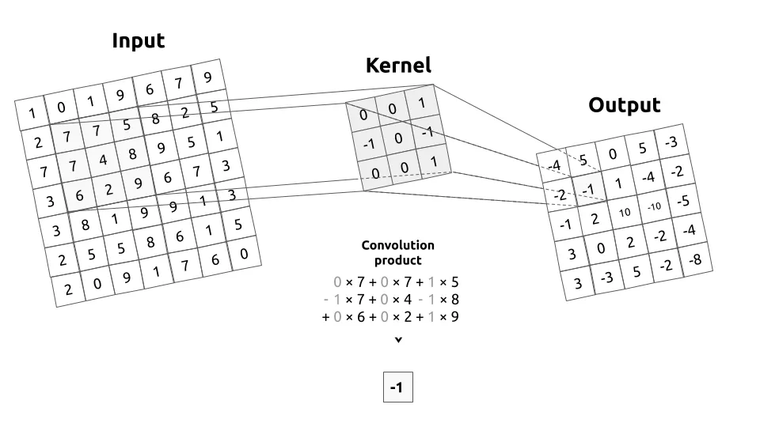

- Max pooling Layer:

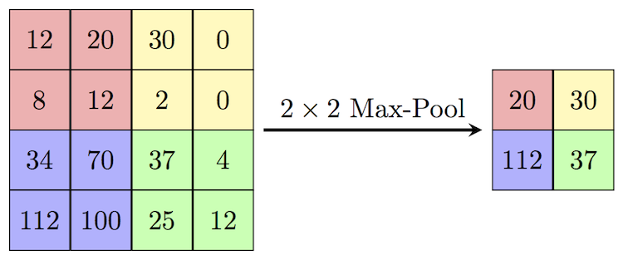

This works by selecting the maximum value from every pool.

5.Project Plan and Timeline
Phase | Duration | Tasks
Phase1:Planning and Requirement Analysis | June 2024 - June 30, 2024 | Define project scope, objectives, and requirements  Identify stakeholders and gather user requirements  Develop a project plan and timeline
Phase 2: Design and Architecture | July 2024 - July 31, 2024 | Create system architecture and design Develop detailed UI/UX designs and wireframes  Design database schema and data models
Phase 3: Development and Implementation | August 2024 - October 31,  2024 | Set up the development environment Implement core functionalities and features Integrate convolutional Neural Network (ConvNet/CNN) is Deep Learning Algorithm which can take in an input image,  assign important (Learnable weights and biases) to various aspects/objects in the Image and able to differentiate one from the other.
Phase 4: Testing and Quality Assurance | November 2024  November 30, 2024 | Conduct unit testing and integration testing Perform user acceptance testing  Fix bugs and optimize performance Ensure compliance with data privacy and security standards
Phase 5: Deployment and Launch | December 2024 -  December 15, 2024 | Prepare deployment infrastructure  Deploy the app to production environment Monitor initial user feedback and performance

6.Expected Outcomes

- Enhanced Disease Detection: The development of a robust disease detection system based on Convolutional Neural Networks (CNNs) is expected to significantly improve the accuracy of identifying bacterial blight and other diseases in pomegranate leaves. This system will enable precise differentiation between healthy and diseased leaves, allowing for timely and targeted interventions.
- Empowerment of Farmers: By providing farmers with advanced tools for early disease detection, the system will empower them to take proactive measures in managing their orchards. Early detection will reduce the spread of disease, lower crop losses, and improve overall yield and fruit quality, thereby enhancing the economic stability of pomegranate growers.
- Broader Agricultural Applications: While the immediate focus is on pomegranate cultivation, the success of this CNN-based detection system has the potential to extend its impact beyond pomegranates to other crops. The adaptability of the technology could revolutionize disease management practices in diverse agricultural settings, promoting healthier crops and more sustainable farming practices.
- Increased Research and Innovation: The promising results from this initiative underscore the need for continued investment in agricultural research and innovation. Further advancements in AI and machine learning for disease detection could lead to even more sophisticated and efficient tools, driving ongoing improvements in agricultural productivity and sustainability.
- Sustainable Future for Pomegranate Agriculture: By integrating advanced disease detection technologies into pomegranate cultivation, we can ensure a brighter future for this valuable crop. The system will contribute to more sustainable farming practices, reduced reliance on chemical treatments, and improved environmental outcomes, ultimately securing the long-term viability and prosperity of pomegranate agriculture.

7.References
1. Li, Y., Sahu, P., Yang, S., & Kanhere, S. S. (2020). Edge Intelligence: Paving the Last Mile of Artificial Intelligence with Edge Computing. IEEE Network, 34(5), 96-102.
2. Huang, G., Liu, Z., Van Der Maaten, L., & Weinberger, K. Q. (2017). Densely Connected Convolutional Networks. Proceedings of the IEEE Conference on Computer Vision and Pattern Recognition (CVPR).
3. Tan, M., & Le, Q. V. (2019). Efficient Net: Rethinking Model Scaling for Convolutional Neural Networks. Proceedings of the 36th International Conference on Machine Learning (ICML).
4. Fuentes, A., Yoon, S., Kim, S. C., & Park, D. S. (2017). A robust deep-learning-based detector for real-time tomato plant diseases and pests’ recognition. Sensors, 17(9), 2022.
5. Mohanty, S. P., Hughes, D. P., & Salathé, M. (2016). Using deep learning for image-based plant disease detection. Frontiers in Plant Science, 7, 1419.
6. Lundberg, S. M., & Lee, S. I. (2017). A unified approach to interpreting model predictions. Advances in Neural Information Processing Systems (NeurIPS).
7. Ribeiro, M. T., Singh, S., & Guestrin, C. (2016). "Why Should I Trust You?" Explaining the Predictions of Any Classifier. Proceedings of the 22nd ACM SIGKDD International Conference on Knowledge Discovery and Data Mining (KDD).
9. Riihijärvi, J., & Piche, R. (2009). Design of Delay-Tolerant Mobile Applications.
FAO (Food and Agriculture Organization of the United Nations). (2018). Digital agriculturefor inclusive rural development. FAO Agriculture and Consumer Protection Working Paper.
10. He, K., Zhang, X., Ren, S., & Sun, J. (2016). Deep Residual Learning for Image Recognition. Proceedings of the IEEE Conference on Computer Vision and Pattern Recognition (CVPR).

(Dr.Vijaya Choudhari) (Prof.Archana Dongerdive) (Dr.Poonam Gupta)
Project Guide Project Coordinator HOD

